# Assignment-8

1. What is a user-defined function in shell scripting? Explain with an example. ?

Answer->

A user-defined function in shell scripting is a block of reusable code that performs a specific task and can be called multiple times in a script.

Function helps making script modular and easier to debug or maintain.

Syntax-> funcation_name() {

Commands

}

* First create a file using nano
* Then write a program in the file and then execute it.
* ┌──(kumya㉿sonic)-[~]

└─$ nano greet.sh

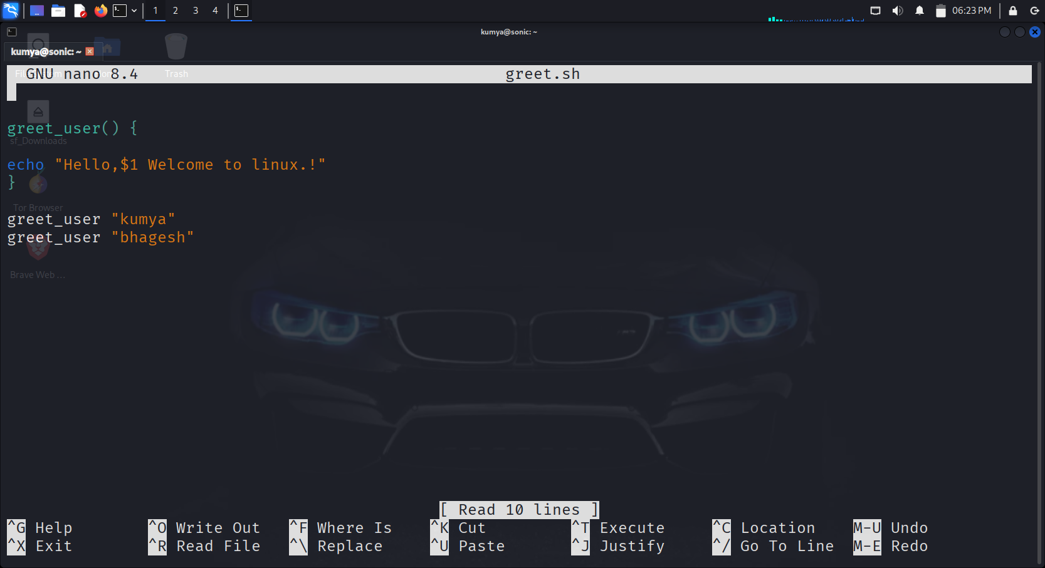

* ┌──(kumya㉿sonic)-[~]

└─$ bash greet.sh

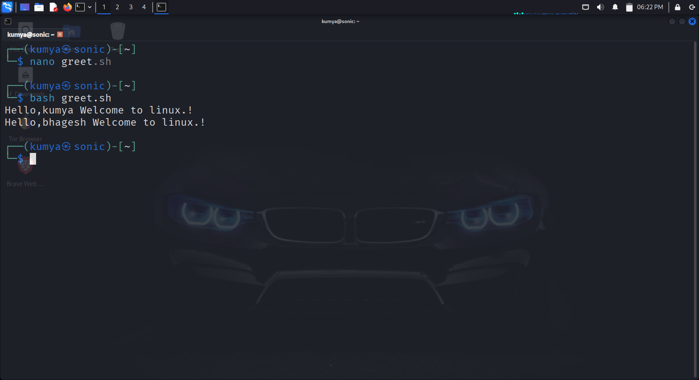

1. Write a bash script with a function that multiply two integer numbers. ?

Answer->

* ┌──(kumya㉿sonic)-[~]

└─$ kwrite multiply.sh

* multiply() -> defines the function
* $1 and $2 -> represents the first and second arguments passed to the function.
* $(( )) -> used for arithmetic operations in bash
* Multiply $num1 $num2 -> calls the function with user input
* ┌──(kumya㉿sonic)-[~]

└─$bash multiply.sh

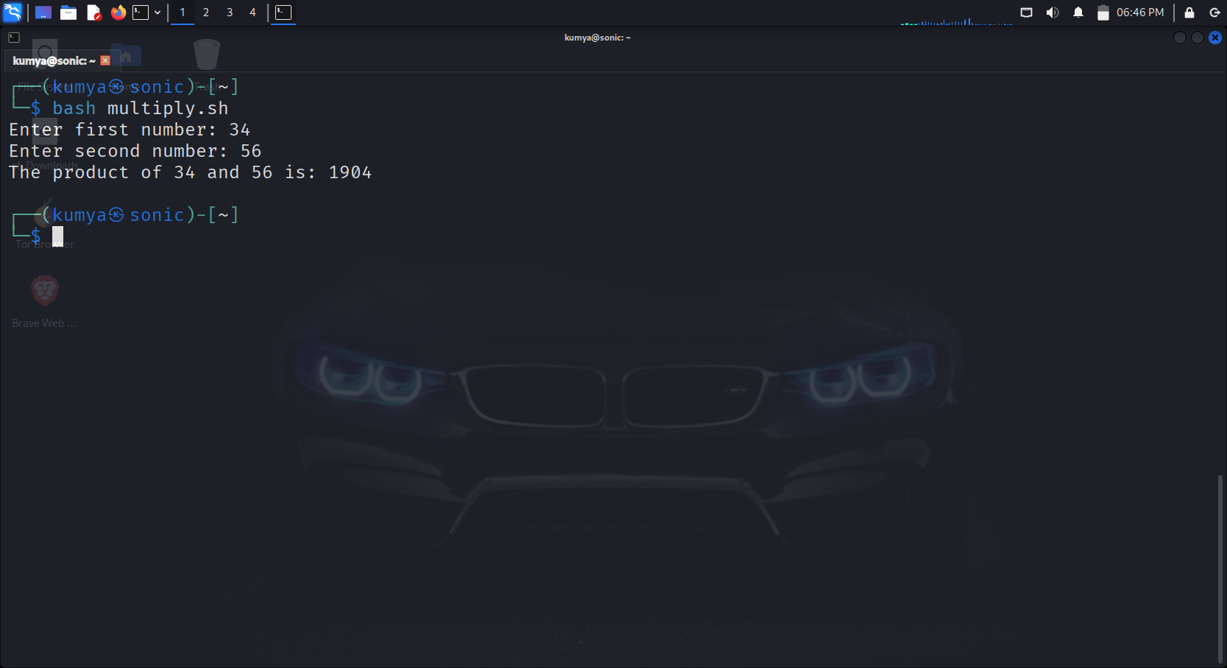

1. Explain how arrays (1D, 2D, and 3D) are declared in bash scripting ?

Answer->

* 1D Array…
* ┌──(kumya㉿sonic)-[~]

└─$ kwrite 1darray.sh

* ┌──(kumya㉿sonic)-[~]

└─$bash 1darray.sh

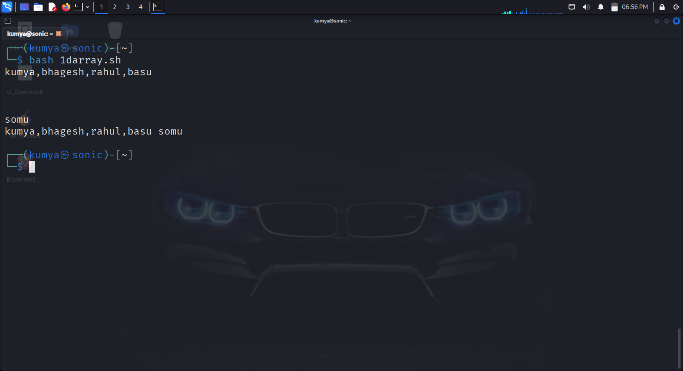

* 2D array….
* ┌──(kumya㉿sonic)-[~]

└─$ kwrite 2darray.sh

* ┌──(kumya㉿sonic)-[~]

└─$ bash 2darray.sh

* 3D Array…
* ┌──(kumya㉿sonic)-[~]

└─$ kwrite 3darray.sh

* ┌──(kumya㉿sonic)-[~]

└─$ bash 3darray.sh

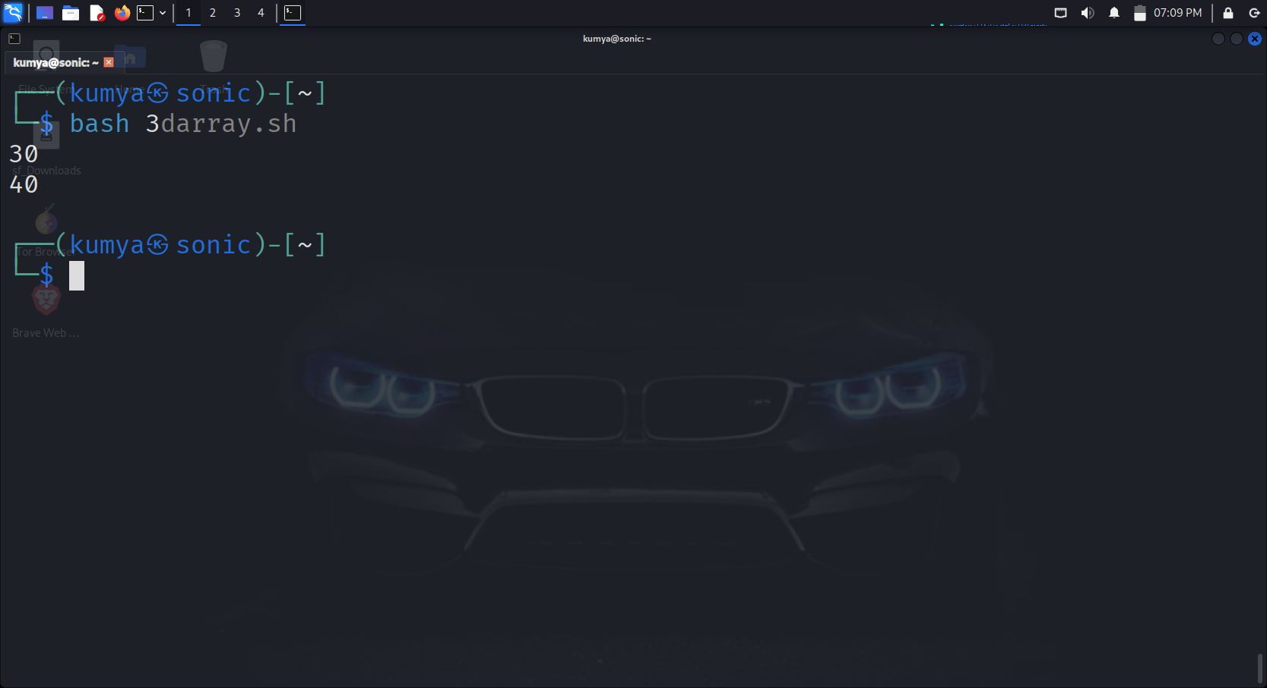

1. Write a shell script to display elements of an array ?

Answer->

* ┌──(kumya㉿sonic)-[~]

└─$ kwrite array.sh

* ┌──(kumya㉿sonic)-[~]

└─$ bash array.sh

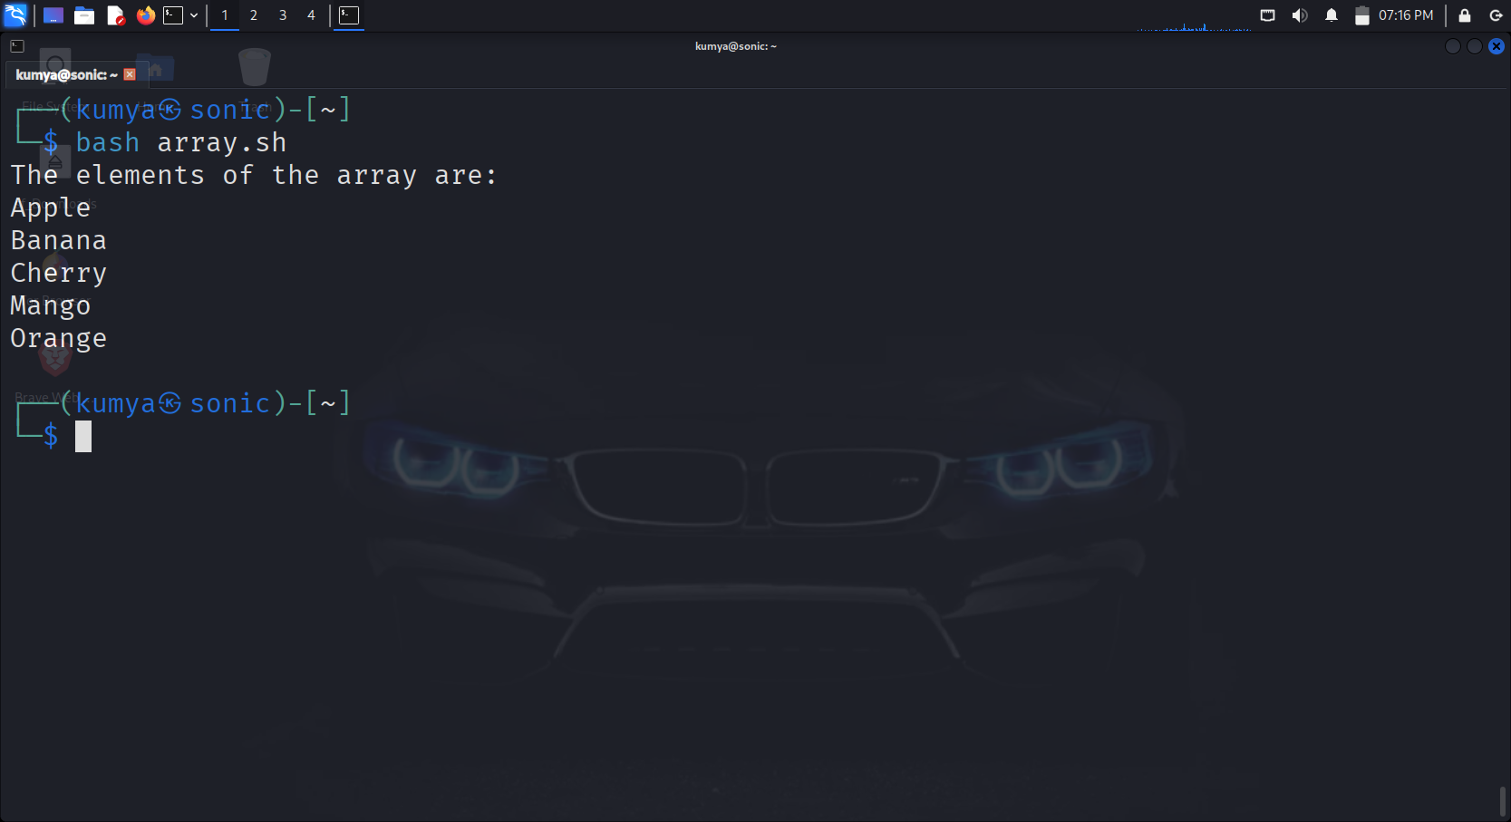

1. What is the purpose of cron in Linux ?

Answer->

Cron is a **time-based job scheduler** in Unix/Linux systems.  
It runs background jobs (called **corn jobs**),, at fixed times, dates, or intervals.

* * * * * * command_to_run
* │ │ │ │ │
* │ │ │ │ └── Day of the week (0–6, Sunday = 0)
* │ │ │ └──── Month (1–12)
* │ │ └────── Day of the month (1–31)
* │ └──────── Hour (0–23)
* └────────── Minute (0–59)
* crontab -e -> to edit the
* corntab -e -> to list existing corntab
* ┌──(kumya㉿sonic)-[~]

└─$ 30 2 * * * /home/kumya/backup.sh

* Backups everyday at 2:30

1. Write a cron job to run a backup script every day at midnight ?

Answer->

| * **Field** | * **Value** | * **Meaning** |
| --- | --- | --- |
| * Minute | * 0 | * Run at minute 0 |
| * Hour | * 0 | * Run at hour 0 (midnight) |
| * Day of Month | * * | * Every day of the month |
| * Month | * * | * Every month |
| * Day of Week | * * | * Every day of the week |
| * Command | * /home/user/backup.sh | * The script to run |

* chmod +x /home/user/backup.sh
* make sure the script has execution permission.

1. How do you schedule a one-time job using at command?

Answer->

* First install the at function
* ┌──(kumya㉿sonic)-[~]

└─$ sudo apt install at

sudo systemctl enable --now atd

* ┌──(kumya㉿sonic)-[~]
* └─$ at 3:20
* Runs the job at 3:20 a particular job.
* at> /home/user/backup.sh
* at> <Press Ctrl+D to save>
* it’s a pre defined function in linux we should just press Ctrl+D and enter the job to be done.

1. Write a script to display disk usage using df and du. ?

Answer->

* ┌──(kumya㉿sonic)-[~]

└─$ kwrite disk_usage.sh

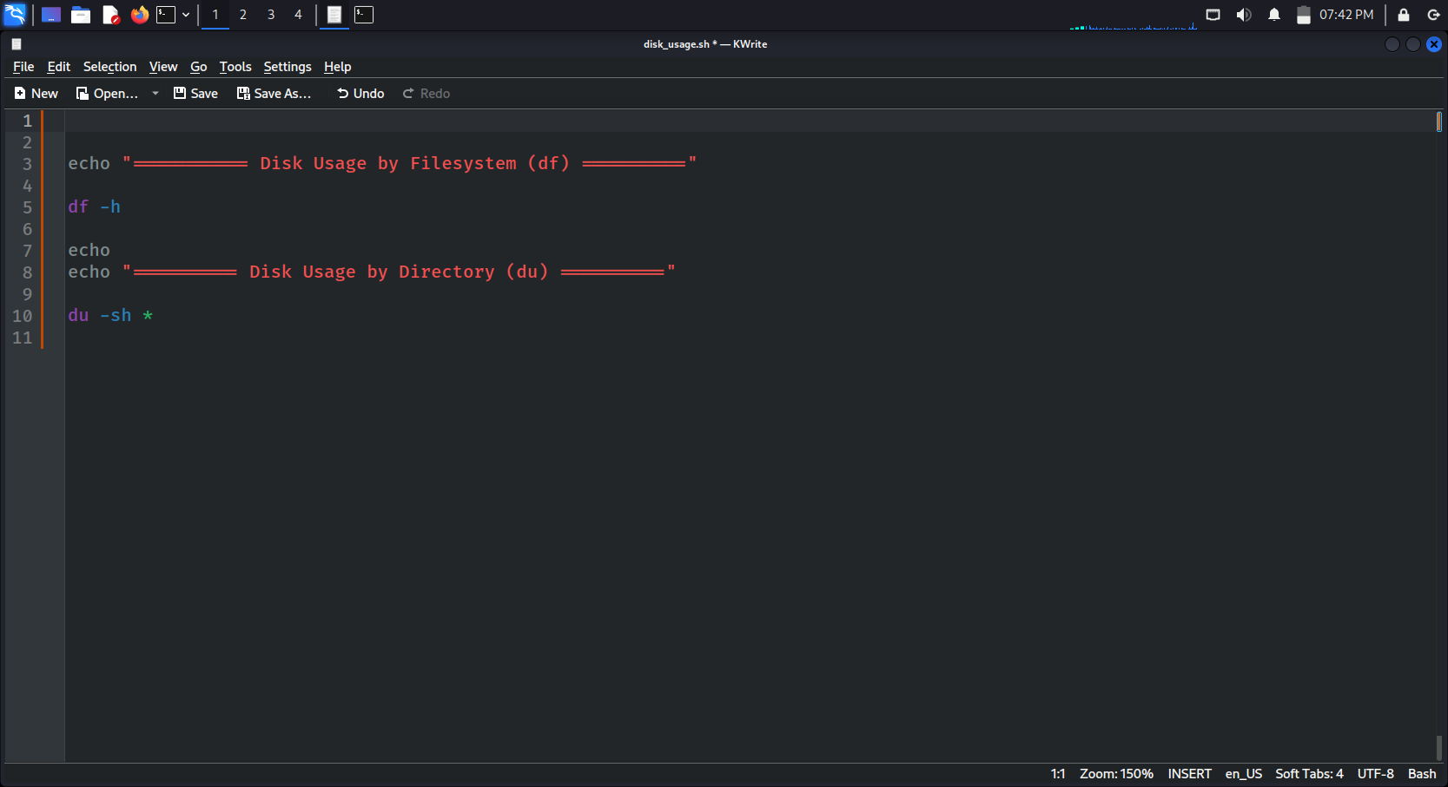

* ┌──(kumya㉿sonic)-[~]

└─$ bash disk_usage.sh

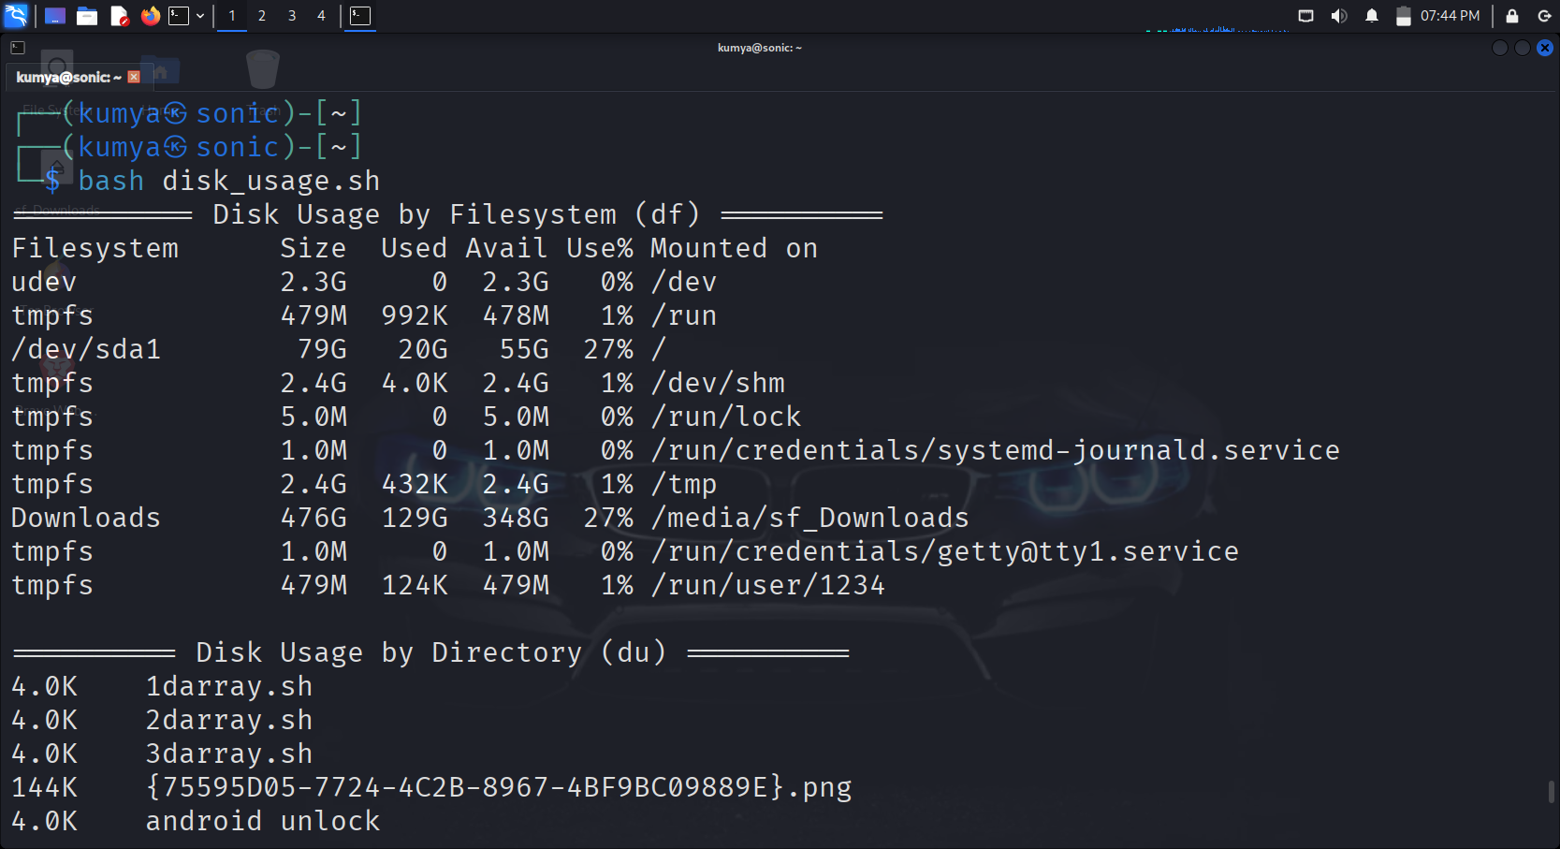

1. How can you log the output of a script using the tee command ?

Answer->

* The file is already made just give a execution permission using a command.
* ┌──(kumya㉿sonic)-[~]

└─$chmod +x disk_usage.sh

* ┌──(kumya㉿sonic)-[~]

└─$ ./disk_usage.sh | tee disk_report.log

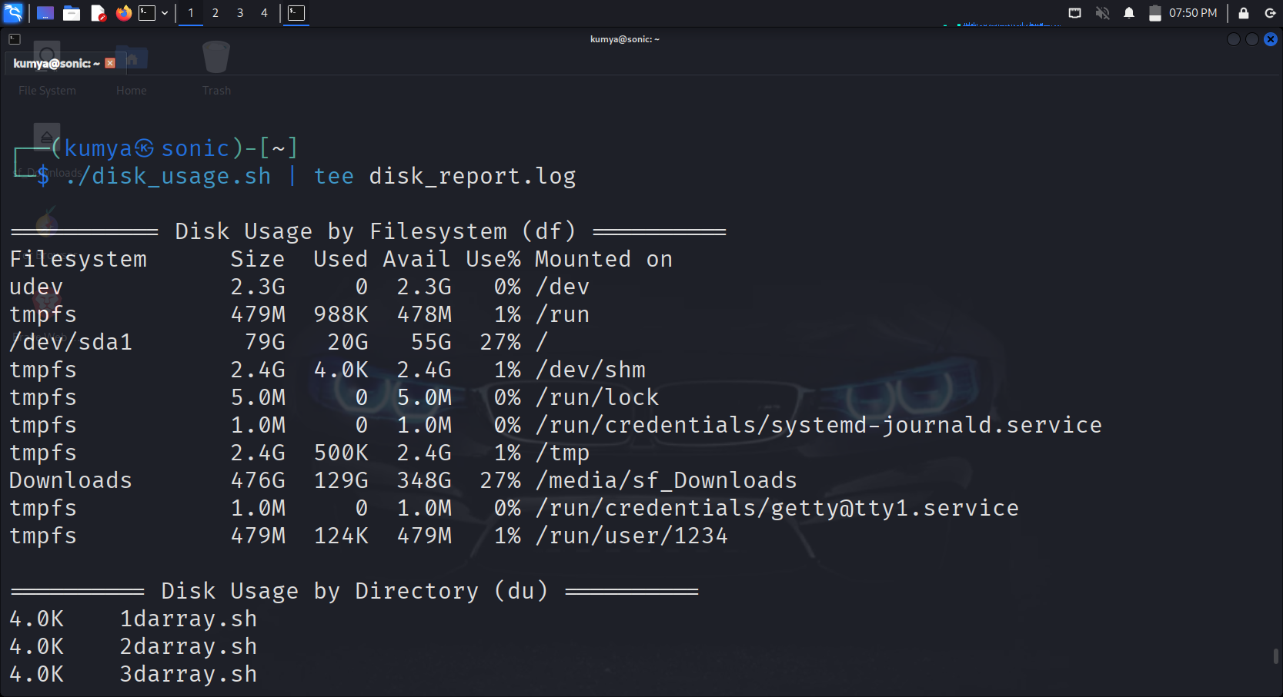

1. Explain with an example how shell scripting can automate system administration tasks. ?

Answer->

Shell scripting allows system administrators to automate repetitive tasks in linux or unix system . by writing a scrip can be executed sequencly without manual intervention, saving time

* ┌──(kumya㉿sonic)-[~]

└─$ kwrite disk_cleanup.sh

* ┌──(kumya㉿sonic)-[~]

└─$ bash disk_cleanup.sh

----------------------------------------------------------------------------------END------------------------------------------------------------------------